Project : Capstone II

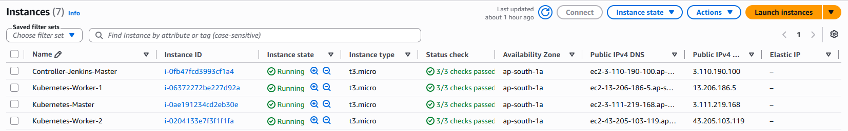

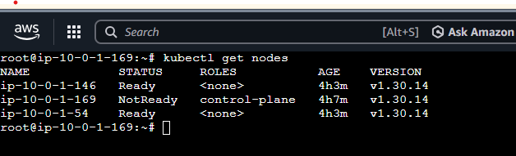
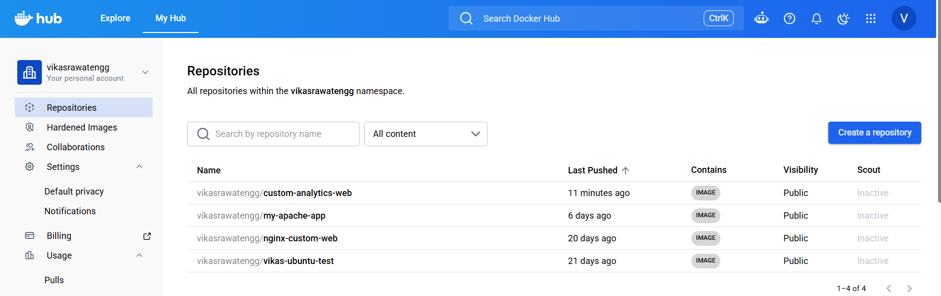
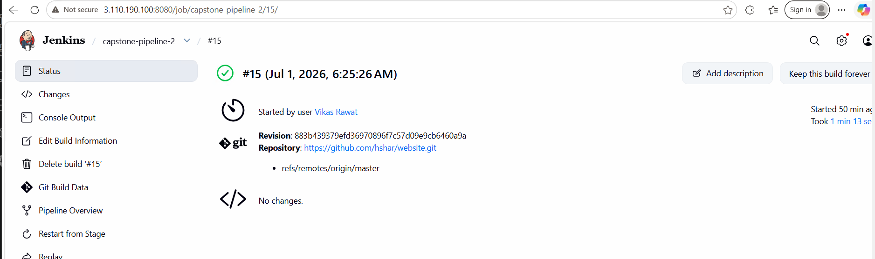
Started by user Vikas Rawat
[Pipeline] Start of Pipeline
[Pipeline] node
Running on Jenkins in /var/lib/jenkins/workspace/capstone-pipeline-2
[Pipeline] {
[Pipeline] withEnv
[Pipeline] {
[Pipeline] stage
[Pipeline] { (Pull Source Code)
[Pipeline] git
The recommended git tool is: NONE
No credentials specified
> git rev-parse --resolve-git-dir /var/lib/jenkins/workspace/capstone-pipeline-2/.git # timeout=10
Fetching changes from the remote Git repository
> git config remote.origin.url https://github.com/hshar/website.git # timeout=10
Fetching upstream changes from https://github.com/hshar/website.git
> git --version # timeout=10
> git --version # 'git version 2.34.1'
> git fetch --tags --force --progress -- https://github.com/hshar/website.git +refs/heads/*:refs/remotes/origin/* # timeout=10
> git rev-parse refs/remotes/origin/master^{commit} # timeout=10
Checking out Revision 883b439379efd36970896f7c57d09e9cb6460a9a (refs/remotes/origin/master)
> git config core.sparsecheckout # timeout=10
> git checkout -f 883b439379efd36970896f7c57d09e9cb6460a9a # timeout=10
> git branch -a -v --no-abbrev # timeout=10
> git branch -D master # timeout=10
> git checkout -b master 883b439379efd36970896f7c57d09e9cb6460a9a # timeout=10
Commit message: "modified"
> git rev-list --no-walk 883b439379efd36970896f7c57d09e9cb6460a9a # timeout=10
[Pipeline] sh
+ echo FROM hshar/webapp:latest
+ echo COPY . /var/www/html/
+ echo EXPOSE 80
+ echo CMD ["apache2ctl", "-D", "FOREGROUND"]
[Pipeline] }
[Pipeline] // stage
[Pipeline] stage
[Pipeline] { (Build Custom Container)
[Pipeline] sh
+ docker build -t vikasrawatengg/custom-analytics-web:15 .
DEPRECATED: The legacy builder is deprecated and will be removed in a future release.
Install the buildx component to build images with BuildKit:
https://docs.docker.com/go/buildx/

Sending build context to Docker daemon 268.3kB
Step 1/4 : FROM hshar/webapp:latest
---> 3c7cbcab1a26
Step 2/4 : COPY . /var/www/html/
---> 9e6c7e4b3a15
Step 3/4 : EXPOSE 80
---> Running in 6f2811d7370e
---> Removed intermediate container 6f2811d7370e
---> 055d4cb8e129
Step 4/4 : CMD ["apache2ctl", "-D", "FOREGROUND"]
---> Running in 91a356cbbe70
---> Removed intermediate container 91a356cbbe70
---> 05ec7d3d714b
Successfully built 05ec7d3d714b
Successfully tagged vikasrawatengg/custom-analytics-web:15
[Pipeline] sh
+ docker tag vikasrawatengg/custom-analytics-web:15 vikasrawatengg/custom-analytics-web:latest
[Pipeline] }
[Pipeline] // stage
[Pipeline] stage
[Pipeline] { (Push to Docker Hub)
[Pipeline] withCredentials
Masking supported pattern matches of $PASS
[Pipeline] {
[Pipeline] sh
+ echo ****
+ docker login -u vikasrawatengg --password-stdin
Login Succeeded
[Pipeline] sh
+ docker push vikasrawatengg/custom-analytics-web:15
The push refers to repository [docker.io/vikasrawatengg/custom-analytics-web]
c6597f501c2e: Pushed
15: digest: sha256:05ec7d3d714b3fad46c8e6feab58142ace3dec94627de0ec5af3a3dc45c8d881 size: 2308
[Pipeline] sh
+ docker push vikasrawatengg/custom-analytics-web:latest
The push refers to repository [docker.io/vikasrawatengg/custom-analytics-web]
latest: digest: sha256:05ec7d3d714b3fad46c8e6feab58142ace3dec94627de0ec5af3a3dc45c8d881 size: 2308
[Pipeline] }
[Pipeline] // withCredentials
[Pipeline] }
[Pipeline] // stage
[Pipeline] stage
[Pipeline] { (Deploy to Kubernetes Cluster)
[Pipeline] withCredentials
Masking supported pattern matches of $KEY
[Pipeline] {
[Pipeline] echo
=== CONNECTING TO KUBERNETES MASTER VIA NATIVE SSH ===
[Pipeline] sh
+ ssh -i **** -o StrictHostKeyChecking=no ubuntu@3.111.219.168 kubectl apply -f app-deployment.yaml && kubectl apply -f app-service.yaml
deployment.apps/analytics-prod-app unchanged
service/analytics-nodeport-svc unchanged
[Pipeline] sh
+ ssh -i **** -o StrictHostKeyChecking=no ubuntu@3.111.219.168 kubectl rollout restart deployment/analytics-prod-app
deployment.apps/analytics-prod-app restarted
[Pipeline] }
[Pipeline] // withCredentials
[Pipeline] }
[Pipeline] // stage
[Pipeline] }
[Pipeline] // withEnv
[Pipeline] }
[Pipeline] // node
[Pipeline] End of Pipeline
Finished: SUCCESS
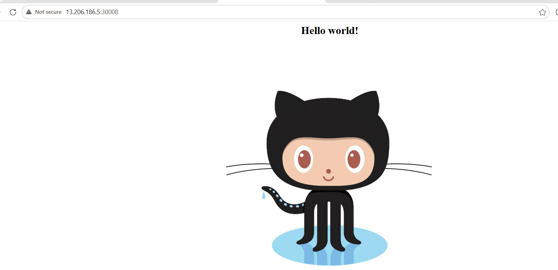

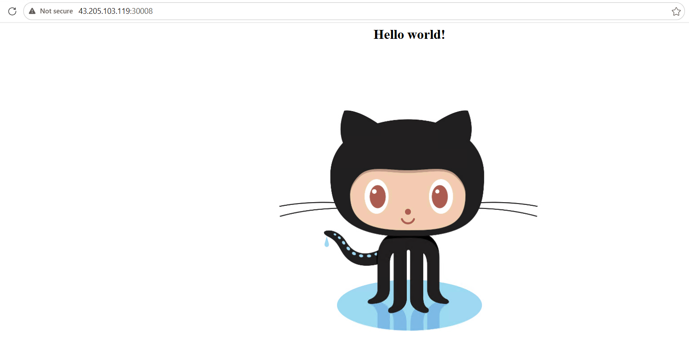

pipeline {
agent any
environment {
DOCKER_USER = "vikasrawatengg"
REGISTRY_IMAGE = "vikasrawatengg/custom-analytics-web"
K8S_MASTER_IP = "3.111.219.168"
}
stages {
stage('Pull Source Code') {
steps {
git branch: 'master', url: 'https://github.com/hshar/website.git'
sh '''
echo "FROM hshar/webapp:latest" > Dockerfile
echo "COPY . /var/www/html/" >> Dockerfile
echo "EXPOSE 80" >> Dockerfile
echo "CMD [\\"apache2ctl\\", \\"-D\\", \\"FOREGROUND\\"]" >> Dockerfile
'''
}
}
stage('Build Custom Container') {
steps {
sh 'docker build -t ${REGISTRY_IMAGE}:${BUILD_NUMBER} .'
sh 'docker tag ${REGISTRY_IMAGE}:${BUILD_NUMBER} ${REGISTRY_IMAGE}:latest'
}
}
stage('Push to Docker Hub') {
steps {
withCredentials([usernamePassword(credentialsId: 'docker-hub-credentials', passwordVariable: 'PASS', usernameVariable: 'USER')]) {
sh 'echo $PASS | docker login -u ${DOCKER_USER} --password-stdin'
sh 'docker push ${REGISTRY_IMAGE}:${BUILD_NUMBER}'
sh 'docker push ${REGISTRY_IMAGE}:latest'
}
}
}
stage('Deploy to Kubernetes Cluster') {
steps {
// Extracts your key as a direct temporary file variable ($KEY) instead of trying to pass it to ssh-add
withCredentials([sshUserPrivateKey(credentialsId: 'k8s-ssh-key-credentials', keyFileVariable: 'KEY')]) {
echo '=== CONNECTING TO KUBERNETES MASTER VIA NATIVE SSH ==='
sh "ssh -i \${KEY} -o StrictHostKeyChecking=no ubuntu@${K8S_MASTER_IP} 'kubectl apply -f app-deployment.yaml && kubectl apply -f app-service.yaml'"
sh "ssh -i \${KEY} -o StrictHostKeyChecking=no ubuntu@${K8S_MASTER_IP} 'kubectl rollout restart deployment/analytics-prod-app'"
}
}
}
}
}

